**Skewness and Kurtosis**

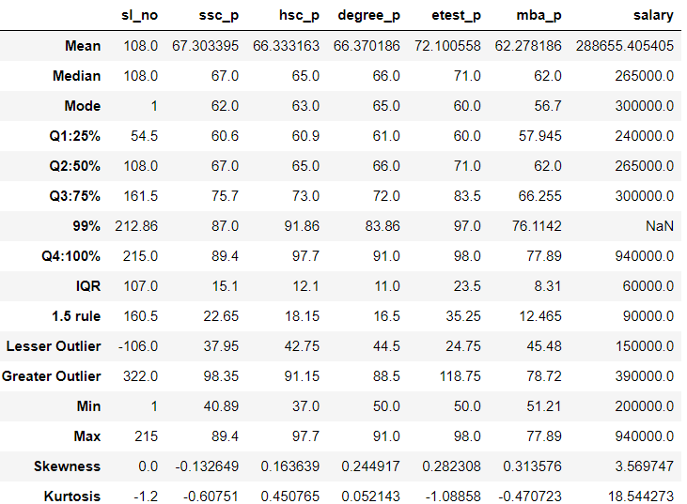

Skewness – is based on Mean, Median, Mode to find the peak information.

The below table shows the skewness of each column

|  |  |  |
| --- | --- | --- |
| Column Name | Value | Skewness |
| Sl_no | 0 | Normal |
| Ssc_p | -0.1326 | Negative |
| Hsc_p | 0.16 | Positive |
| Degree_p | 0.244 | Positive |
| Etest_p | 0.28 | Positive |
| Mba_p | 0.313 | Positive |
| salary | 3.5 | Positive |

Kurtosis – is to get the spread and peak of information. <3 -playkurtic, =3 -mesokurtic, >3-leptokurtic

The below table shows the Kurtosis of each column

|  |  |  |
| --- | --- | --- |
| Column Name | Value | Kurtosis |
| Sl_no | -.1.2 | playkurtic |
| Ssc_p | -0.6075 | playkurtic |
| Hsc_p | 0.45 | playkurtic |
| Degree_p | 0.052 | playkurtic |
| Etest_p | -1.08 | playkurtic |
| Mba_p | -0.47 | playkurtic |
| salary | 18.54 | leptokurtic |